
School of Science, Computing and Engineering Technologies

Object Oriented Programming
Pass Task 2.3: Drawing Program — A Basic Shape

Overview
Drawing programs have a natural affinity with object oriented design and programming, with easy to see roles and functionality. In this task you will start to create an object-oriented drawing program.

Purpose: Task:
Learn to apply object-oriented programming techniques related to the concept of abstraction.
Create a program that can draw rectangular shapes to the screen. The task contains personalized requirements

Deadline: Due by the end of week three, Fri, 16 August 2024 (Firmed).

Submission Details
All students have access to the Adobe Acrobat tools. Please print your solution to PDF and combine it with the screenshots taken for this task.
- C# code files of the classes created.
- Screenshot of running program (i.e., SplashKit window).



Instructions
Over the course of the next few weeks you will develop a simple shape drawing program. You begin by creating a Shape class that allows you to draw a predefined shape to the screen. This task requires SplashKit, a third-party framework for 2D graphics, audio, physics, and animation support. The documentation can be found on the SplashKit website splashkit.io. Some elements of SplashKit can be overwhelming at first, but as you get more familiar with its features, tasks will become easier.
- Install SplashKit. You can find guides for Windows and macOS installation on Canvas.

Note: SplashKit is also available for Linux, but Linux is not supported in COS20007.
- Start an MSYS2 MINGW64 terminal (or Terminal on macOS).
- In your project directory, create a new folder called ShapeDrawer for your new project.
CALLUM FENNESSY
2024-08-20 07:42:46
--------------------------------------------

- Change into directory (i.e., cd) ShapeDrawer.
- Create a new SplashKit project in this folder using skm dotnet new.
- Open ShapeDrawer.csproj in Visual Studio.
- Change Program.cs as follows:

using SplashKitSDK;
namespace ShapeDrawer
{
public class Program
{
public static void Main()
{
Window window = new Window(“Shape Drawer”, 800, 600);
do
{
SplashKit.ProcessEvents(); SplashKit.ClearScreen();
SplashKit.RefreshScreen();
} while (!window.CloseRequested);
}
}
}

Tip: Consult the SplashKit documentation. It contains guides for drawing and event han- dling. In addition, check the Developer Documentation sections on Graphics, Windows, and Input that explain the features used in the above code. Understanding what each line does in the above code is critical to mastering SplashKit.
- Run the program (a window with white background appears on your screen). To close the application, click on × (Windows) or ● (macOS) in the window title.
- Add a Shape class to your project. Use the following UML class diagram as a guide.

Shape
- _color: Color
- _x: Float
- _y: Float
- _width: Integer
- _height: Integer
+ Shape(int param)

+ Color : Color <<property>>

+ X : Float <<property>>
+ Y : Float <<property>>

+ Width : Integer <<property>>
+ Height : Integer <<property>>

+ Draw()
+ IsAt(pt: Point2D) : Boolean
- The type Color is defined in the SplashKitSDK. To use this type and the other drawing ab- stractions, add using SplashKitSDK; at the start of the file Shape.cs. The using statement makes all SplashKit features available in the current compilation unit.

using SplashKitSDK;

namespace ShapeDrawer
{
public class Shape
{
private Color _color;
…
- In the constructor, initialize _color to Color.Azure if the first letter of your first name is from A to
K. Otherwise, set by your Color.Chocolate. In that constructor, set _x and _y to 0.0f (the suffix f makes 0.0 a float value), and both the _width and _height are assigned to the value of a given parameter called param. When you later create objects based on this Shape class, please specify the parameter to be 1XX, where XX is the last two digits of your student ID.

- The Draw method will draw the shape as a filled rectangle using the shape's Color, position, and dimension.

public class Shape
{
…
public void Draw()
{
SplashKit.FillRectangle (_color, _x, _y,
_width, _height);
}

Tip: Visual Studio can assist you in finding the right class or method, Start typing ‘SplashKit’ and Visual Studio will provide you with suggestions to complete a code line.

- Add the IsAt method which takes a Point2D point (a struct that contains an X and Y value representing a point in 2d space - like a point on the screen), and returns a Boolean to indicate if the shape is at that point. You need to return true if the point pt is within the shape's area (as defined by the shape's coordinates).

Tip: What does it mean for a point to be considered inside the area of a rectangle? Note, the boundary of a shape is part of the area. If you get stuck, do not hesitate to seek out help.
- Add all properties (as defined in the UML diagram) to class Shape.
- Return to the Program.cs file.
- In Main,
  - Add a myShape local variable of the type Shape.
  - Assign myShape, a new Shape object.

- Inside the do-while loop in Main:
  - Tell myShape to Draw itself - after clearing the screen.
  - Add an if-statement to check whether the user has clicked the left mouse button. If this is the case, set myShapes’s X and Y coordinates to the mouse position.

Hint: You need to use the SplashKit functions MouseClicked, MouseX, and
MouseY, and use LeftButton as argument to function MouseClicked.
You need to write SplashKit.MouseClicked(MouseButton.LeftButton) to test if the user has clicked the left mouse button, and SplashKit.MouseX() to obtain the x- coordinate of the mouse position.
  - Add an if-statement to test whether the user has pressed the spacebar (use function SplashKit.KeyTyped with KeyCode.SpaceKey). If, at the same time, the mouse pointer hovers over myShape (i.e. the mouse pointer is within the area of myShape), then set myShape’s Color property to a random color value.

Hint: Check out SplashKit’s KeyTyped, MousePosition, and RandomColor func- tions.
  - You need to tell myShape to Draw itself. This should be the last operation before the screen is refreshed. You may need to move the code that tells myShape to Draw.
- Compile and run your program. Try changing myShape’s position and color.

Once your program is complete you can prepare it for your portfolio. This can be placed in your portfolio as evidence of what you have learnt.
- Review your code and ensure it is formatted correctly.
- Run the program and use your preferred screenshot program to take a screenshot of the Terminal showing the program's output.
- Save and backup your work to multiple locations, if possible.
  - Once you your program is working you do not want to lose your work.
  - Work on your computer’s storage device most of the time, but backup your work when you finish each task.
  - You may use a cloud storage provider to safely store your work.
  - USB and portable hard drives are good secondary backups, but there is a risk that the drive gets damaged or lost.

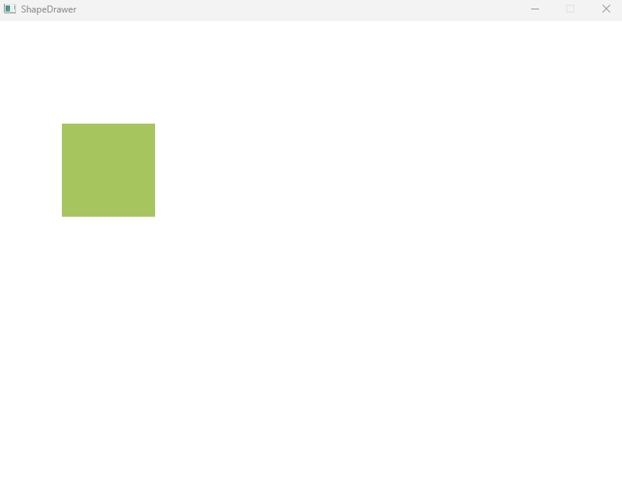

using System;
using SplashKitSDK;

namespace ShapeDrawer
{
public class Program
{
public static void Main()
{
Shape myShape = new Shape(119);
Window window = new Window("ShapeDrawer", 800, 600);
SplashKit.MouseClicked(MouseButton.LeftButton);
SplashKit.MouseX();

do
{
SplashKit.ClearScreen();
myShape.Draw();
if (SplashKit.MouseClicked(MouseButton.LeftButton))
{
myShape._x = SplashKit.MouseX();
myShape._y = SplashKit.MouseY();
}
if (SplashKit.KeyTyped(KeyCode.SpaceKey) && myShape.IsAt(SplashKit.MousePosition()))
{
myShape._color = SplashKit.RandomColor();

}

SplashKit.ProcessEvents();
SplashKit.RefreshScreen();
} while (!window.CloseRequested);

}

}
}
using System;
using System.Collections.Generic;
using System.Linq;
using System.Text;
using System.Threading.Tasks;
using SplashKitSDK;

namespace ShapeDrawer
{
public class Shape
{
public Color _color;
public float _x;
public float _y;
public int _width;
public int _height;

public Shape(int param)
{
_color = Color.Azure;
_x = 0.0f;
_y = 0.0f;
_width = param;
_height = param;
}
public void Draw()
{
SplashKit.FillRectangle(_color, _x, _y,
_width, _height);
}
public bool IsAt(Point2D pt)
{
return pt.X >= _x && pt.X <= _x +_width &&
pt.Y >= _y && pt.Y <= _y + _height;
}

}
}

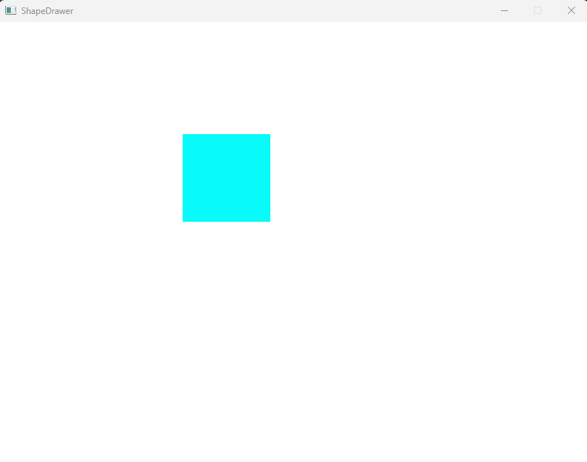

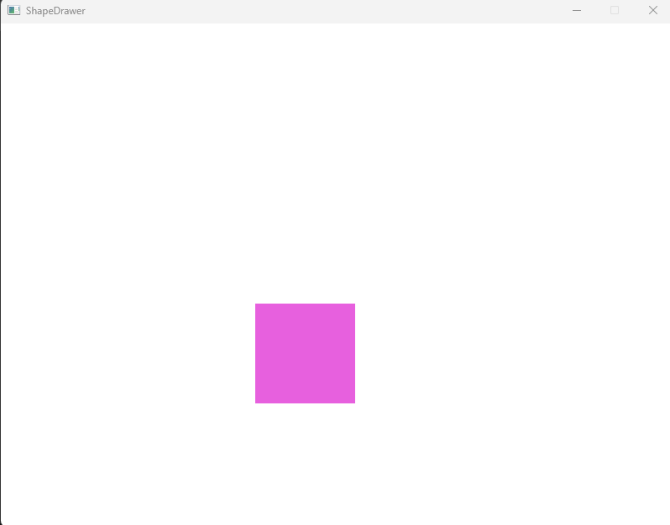

Assessment Criteria
Make sure that your task has the following in your submission:
- The “Universal Task Requirements” (see Canvas) have been met.
- Your program (as text or screenshot).
- Screenshot of application and shape at different positions and different color.

